**LAB 6**

**IP Address Configuration IN LINUX**

In this lab you will learn how to retrieve and modify IP address configuration of a Linux PC (Debian).

1. If you haven't already done this, download the OVA file that matches a Linux-VM (Debian 10 without GUI) to a folder on your laptop.This OVA file can be found in the folder: \\on-nas.howest.be\TI-StudentShare\TI-S2-ComputerNetworks or via <http://gofile.me/48XmW/99dMmBJlU> (VPN required). The VM has a user: ‘mickey’, with password: ‘mouse’. The root user has password: ‘toor’.   
   Double-click the OVA file to import it into your VMware Workstation. Make sure that the VM is stored in a folder on your laptop that you do not sync with a cloud solution!
2. Start your new Linux-VM and sign in with the user *mickey* and password *mouse*.
3. Using the command link layer below, request information about all network adapters.

**ip link show**

*or shorter:*

**ip l**

Paste below a screenshot of the output of your command.

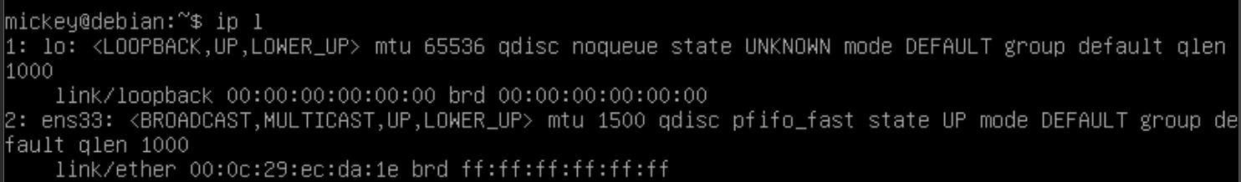

Normally, info about (at least) 2 adapters is shown: A loopback adapter, named *lo* (to be discussed later in the course) and another adapter with the name *ens33*. This is the name of the NIC of your VM.

Adjust your command so you only get info about the ens33 interface.

ip l show ens33

The most important information displayed with this command is address information.Write down this address below:

00:0c:29:ec:da:1e

Adjust your command so that only the address is shown, by passing it on to other basic linux commands as you’ve seen last semester (remember piping?)

Is this an MAC address or an IP address?

MAC adress

How do you know this?

The output is showing link layer information and the output consists of 48 bits.

1. Request information about all network adapters in your VM using the “ip address” command below.

**ip address show**

or shorter:

**ip a**

Paste below a screenshot of the output of your command.

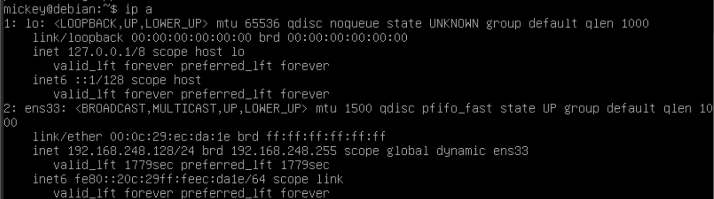

Adjust your command so you only get info about the *ens33* adapter.

ip a show ens33

With this command you get both MAC and IP addresses.Write down the IPv4 address of *ens33* below:

192.168.248.128

Adjust your previous command with an extra option so that you only see IPv4 address information. (Remember man pages?)

Ip -4 a show ens33

1. Check if you can ping from your host to your Linux-VM.

Note that Debian Linux does this by default without modifying the firewall (sometimes different for other Linux distributions).

1. Change the IP address of your NIC as follows:
2. Using an appropriate command, adjust the contents of the configuration file***/etc/network/interfaces*** so that it looks like this, replacing the number 140 with the value of “your” x for your VMnet8 setting in VMware (see previous lab on Windows IP configuration).

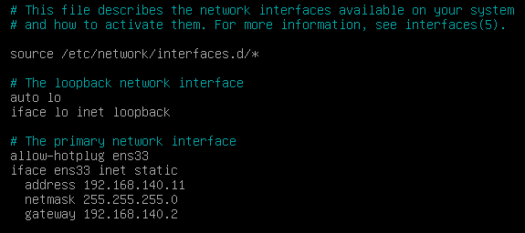

sudo nano /etc/network/interfaces

b) Re-enable the network *adapter* ens33 with the following commands:

***sudo ifdown ens33***

***sudo ifup ens33***

Then, using a command, request the IP address configuration back to check if this is successful.

ip a

1. Finally (optionally), let’s have a look at your smartphone, if you have one. Connect to an available WLAN on your smartphone and then request the MAC address and IP address from your smartphone (from the Wi-Fi interface). Note below which menu choices you have made for this purpose (look in your ‘Settings’ somewhere).

Apple iPhone:

Settings > General > Info

Write down the IPv4 address of your smartphone below.

192.168.1.15

Check if you can ping from your host to this address.

It works.

1. Using the first 6 hexas of an MAC address, the manufacturer of the network card can be traced by using an online MAC address vendor lookup tool, such as e.g. <https://macvendors.com/>.

Use this to find out the manufacturer of the NIC of your smartphone.

Network card by Apple, Inc.

In one the upcoming lectures, you’ll learn why it is possible to figure that out.